1. EEGNet hyper-parameter details
To describe the CNN in Supplementary Table 1 we will refer to the hyper-parameters of the involved layers. Each convolutional layer is characterized by the number of convolutional kernels ($K$), kernel size ($F$), stride size ($S$) and padding size ($P$). In addition, depthwise convolution introduced also a depth multiplier ($D$) specifying the number of kernels to learn for each input feature map. Hyper-parameters will be denoted by a superscript and a subscript. The superscript indicates the specific block the layer belongs to, using the acronyms “ST”, “T”, “FC”. The subscript indicates which convolutional layer inside the block the hyper-parameters refer to (starting from 0). Lastly, pooling layers were described by pool size ($F_{p}$) and stride ($S_{p}$), with the corresponding superscript. Both convolutions and poolings were 2D; thus, $F$, $S$, $P$, $F_{p}$, $S_{p}$ were tuples of two integers: the first referred to the spatial dimension, while the second to the temporal dimension. Lastly, the temporal dimension changed across pooling operators and was denoted with $T_{p}$. Regarding the fully-connected layer in the last block, the number of neurons was denoted with${ N}^{FC}$ and was equal to the number of classes to decode ($N_{c}=3$).
The adopted EEGNet was lightly different from the original formulation [1]. In particular, since EEGNet was designed to accept EEG signals sampled at 128 Hz as input, we scaled down the temporal pool sizes and kernel lengths accordingly. In addition, due to the compact size of the used dataset, we further reduced the number of trainable parameters to fit by using a unitary depth multiplier in all depthwise convolutions (both in the spatio-temporal block and in the temporal block). Lastly, we did not exploit kernel max norm constraint in the architecture as it resulted detrimental for the performance in previous analyses on the same dataset.

2. Hierarchical agglomerative clustering details
In the following, the distance metric adopted to apply the hierarchical agglomerative clustering (HAC) is described. During HAC, pairwise distances between observations in T-dimensional space were computed, indicating with $T$ the number of time samples (as in the manuscript). The two observations corresponded to two temporal saliency patterns belonging to two different subjects (i.e., subject-specific temporal saliency patterns). The correlation between $u,v∈R^{T}$ was computed to define a correlation distance metric $d\left(u,v\right)$ as:
$d\left(u,v\right)=1-\frac{\left(u-\overline{u}\right)∙\left(v-\overline{v}\right)}{{\left\|\left(u-\overline{u}\right)\right\|}_{2}{\left\|\left(v-\overline{v}\right)\right\|}_{2}}$,
where $\overline{u}$,$\overline{v}$ are the mean values of the arrays $u$ and $v$, while $∙$ denotes the dot product.

Supplementary Table 1. Architecture details of the used EEGNet adaptation. Each layer is provided with its name, main hyper-parameters and number of trainable parameters. The total number of trainable parameters was 1259. In all layers, where not specified, stride ($S$) and padding ($P$) were set to $(1,1)$ and $(0,0)$, respectively. The number of channels and time samples provided as input to the CNN were $C=60$ and $T=100$, see Section 2.3 in the manuscript. The temporal dimension changed from $T$ to $T//18$ along the entire CNN (where the symbol//denotes the floor division) due to average poolings.
Block | Layer name | Hyper-parameters | Number of trainable parameters
 | Input | $$K_{0}=1$$ | 0
Spatio-temporal (ST) | Conv2D | ${K_{0}}^{ST}=8$, ${F_{0}}^{ST}=(1,51)$, ${P_{0}}^{ST}=(0,25)$ | $${F_{0}}^{ST}[0]∙{F_{0}}^{ST}[1]∙{K_{0}}^{ST}∙K_{0}$$
Spatio-temporal (ST) | BatchNorm2D | $$momentum=0.99$$ | $$2∙{K_{0}}^{ST}$$
Spatio-temporal (ST) | Depthwise-Conv2D | ${D_{1}}^{ST}=1$, ${K_{1}}^{ST}={K_{0}}^{ST}∙{D_{1}}^{ST}$,  $${F_{1}}^{ST}=(C,1)$$ | $${F_{1}}^{ST}[0]∙{F_{1}}^{ST}[1]∙{K_{1}}^{ST}$$
Spatio-temporal (ST) | BatchNorm2D | $$momentum=0.99$$ | $$2∙{K_{1}}^{ST}$$
Spatio-temporal (ST) | ELU |  | 0
Spatio-temporal (ST) | AvgPool2D | ${F_{p}}^{ST}={S_{p}}^{ST}=(1,3)→{T_{p}}^{ST}=T//3$ | 0
Spatio-temporal (ST) | Dropout | $$p=0.5$$ | 0
Temporal (T) | Separable-Conv2D | ${D_{0}}^{T}=1, {K_{0}}^{T}={K_{1}}^{ST}∙{D_{0}}^{T}$,  ${F_{0}}^{T}=(1,17)$, ${P_{0}}^{T}=(0,8)$ | $${F_{0}}^{T}\left[0\right]·{F_{0}}^{T}\left[1\right]·{K_{0}}^{T}+{\left({K_{0}}^{T}\right)}^{2}$$
Temporal (T) | BatchNorm2D | $$momentum=0.99$$ | $$2∙{K_{0}}^{T}$$
Temporal (T) | ELU |  | 0
Temporal (T) | AvgPool2D | $${F_{p}}^{T}={S_{p}}^{T}=(1,6)→{T_{p}}^{ST}=T//18$$ | 0
Temporal (T) | Dropout | $$p=0.5$$ | 0
Fully-connected (FC) | Flatten |  | 0
Fully-connected (FC) | Fully-Connected | $$N^{FC}=3$$ | $$N^{FC}∙{{(T}_{p}}^{T}∙{K_{0}}^{T}+1)$$
Fully-connected (FC) | Softmax |  | 0

Supplementary Table 2. F1 scores and AUPRs for the target and distractor conditions while training CNNs with the LOSO and WS training strategies (mean value ± standard error of the mean). It is worth noticing that these results are similar or slightly lower (for the WS strategy) than state-of-the-art results reported at the level of single trial in binary P3 classification tasks (discriminating only standard vs. target) [2], despite here a more challenging, three-class classification problem is addressed.
Training strategy | Class | F1 score (%) | AUPR (%)
LOSO | Target | 37.3 ± 2.3 | 38.0 ± 2.7
LOSO | Distractor | 48.5 ± 1.8 | 51.0 ± 2.1
WS | Target | 35.2 ± 1.8 | 45.1 ± 2.1
WS | Distractor | 34.7 ± 1.8 | 47.1 ± 2.2

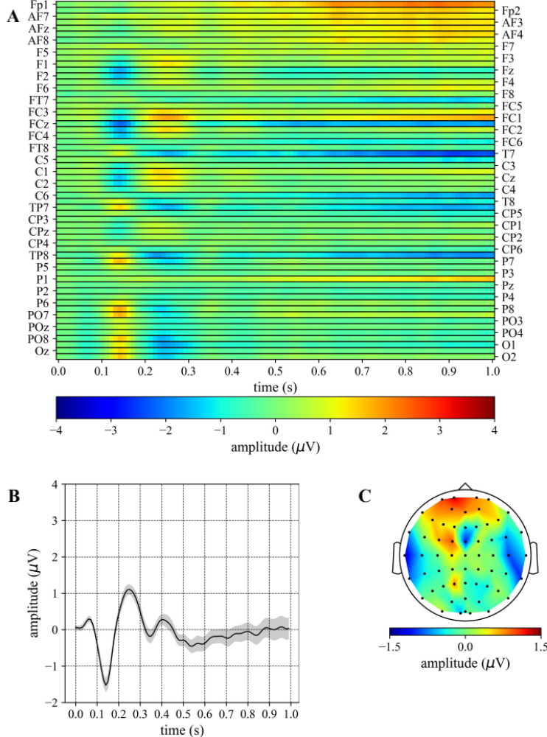
Supplementary Fig. 1. ERP of the standard condition. (A) The grand average is reported as a 2D heatmap with electrodes and time steps along rows and columns, respectively. (B) The average temporal pattern obtained by averaging the 2D heatmap of panel A across the subset of electrodes: FC1, FC2, C1, C2, CP1, CP2. The shaded area represents the mean value ± standard error of the mean, while the thick line represents the mean value. (C) Topological representation of the average contribution of each electrode across all time samples of the 2D heatmap.

References
[1] Lawhern VJ, Solon AJ, Waytowich NR, Gordon SM, Hung CP, Lance BJ. EEGNet: a compact convolutional neural network for EEG-based brain-computer interfaces. Journal of Neural Engineering. 2018; 15: 056013.
[2] Liu M, Wu W, Gu Z, Yu Z, Qi F, Li Y. Deep learning based on Batch Normalization for P300 signal detection. Neurocomputing. 2018; 275: 288–297.

